***PAAREES PERFUMES***

***DAVIDOFF***

***FOR WOMEN***

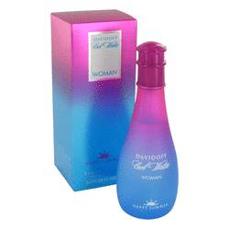

# *Cool Water Happy Summer*

***Description:***

Cool Water Happy Summer by Davidoff Perfume. Created in 2007 by the design house of Davidoff, Cool Water Happy Summer is the perfect daytime fragrance for women who love spending time outdoors. It combines passion fruit, passion flower and jasmine, creating an aroma that's floral and fun. Just a few sprays of this uplifting fragrance will last throughout the day. Wear it before heading out to the park for an afternoon picnic or out for a day of shopping with the girls.